*Console Output:*

sm1's

x is: 7

y is: 30

hatColor is: java.awt.Color[r=0,g=0,b=0]

sm2's

x is: 7

y is: 30

hatColor is: java.awt.Color[r=0,g=0,b=0]

*Game Board Output:*

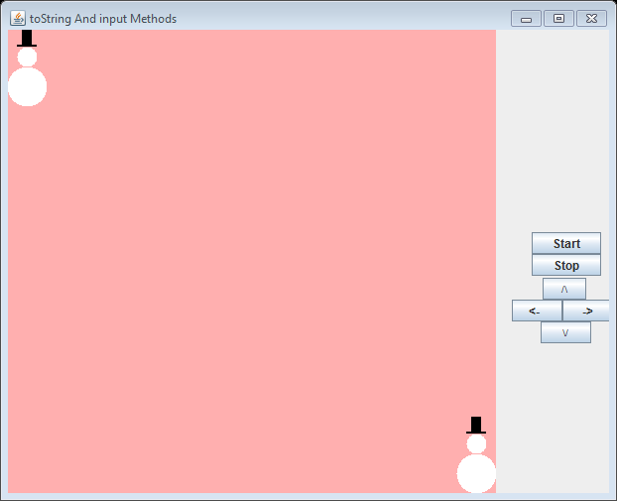 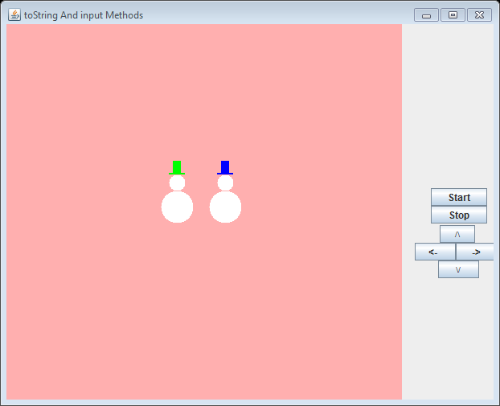

a) b)

**Figure 3.34 The console and game board output from the application ToStringAndInput.**